**A**

**Synopsis**

**on**

**Travel and Tours Website**

**Submitted by:**

**Group. No:- G-B6**

**Parth Maurya -2100290140100**

**Piyush Rajput 2100290140101**

**Vinay Bhardwaj 2100290140149**

**Dushyant University -2100290140063**



**Submitted to :-**

**DR. SHASHANK BHARDWAJ**

**Department of Computer Applications,**

**KIET Group of Institutions,**

**Delhi-NCR, Ghaziabad**

**September’ 2022**

1. Introduction
2. Technologies / Software Requirement

1. Hardware requirement / Hardware Used
2. Modules Description

1. Reports / Outputs
2. Conclusion

INTRODUCTION

Travel and tourism management system is used to book a tour from anywhere in the world

by a single dynamic website which will help the user to know all about the places and tour

details in a single website. The admin can add packages to the website from a certain travel

agents and hotels by create a tour page. Then the users can sign in and book each project,

they can be confirmed by the admin in their manage booking page. The user can see the

confirmation in their my booking page. It is a easiest platform for all travelers which can be

easily booked and know the all details. Tour Management system is a dynamic website for

tourism business. It is dynamic and responsive web design. It is also called travel technology

solution for agencies & tour operation. Nearly Everyone goes on a vacation for this ‘a

Tourism management system’ would play a vital role in planning the perfect trip. The tourism

management system allows the user of the system access all the details such as location,

events, etc. The main purpose is to help tourism companies to manage customer and hotels

etc. The system can also be used for both professional and business trips

**INTRODUCTION:-**

INTRODUCTION

Travel and tourism management system is used to book a tour from anywhere in the world

by a single dynamic website which will help the user to know all about the places and tour

details in a single website. The admin can add packages to the website from a certain travel

agents and hotels by create a tour page. Then the users can sign in and book each project,

they can be confirmed by the admin in their manage booking page. The user can see the

confirmation in their my booking page. It is a easiest platform for all travelers which can be

easily booked and know the all details. Tour Management system is a dynamic website for

tourism business. It is dynamic and responsive web design. It is also called travel technology

solution for agencies & tour operation. Nearly Everyone goes on a vacation for this ‘a

Tourism management system’ would play a vital role in planning the perfect trip. The tourism

management system allows the user of the system access all the details such as location,

events, etc. The main purpose is to help tourism companies to manage customer and hotels

etc. The system can also be used for both professional and business trips

INTRODUCTION

Travel and tourism management system is used to book a tour from anywhere in the world

by a single dynamic website which will help the user to know all about the places and tour

details in a single website. The admin can add packages to the website from a certain travel

agents and hotels by create a tour page. Then the users can sign in and book each project,

they can be confirmed by the admin in their manage booking page. The user can see the

confirmation in their my booking page. It is a easiest platform for all travelers which can be

easily booked and know the all details. Tour Management system is a dynamic website for

tourism business. It is dynamic and responsive web design. It is also called travel technology

solution for agencies & tour operation. Nearly Everyone goes on a vacation for this ‘a

Tourism management system’ would play a vital role in planning the perfect trip. The tourism

management system allows the user of the system access all the details such as location,

events, etc. The main purpose is to help tourism companies to manage customer and hotels

etc. The system can also be used for both professional and business trips

Travel and tourism management system is used to book a tour from anywhere in the world

by a single dynamic website which will help the user to know all about the places and tour

details in a single website. The admin can add packages to the website from a certain travel

agents and hotels by create a tour page. Then the users can sign in and book each project,

they can be confirmed by the admin in their manage booking page. The user can see the

confirmation in their my booking page. It is a easiest platform for all travelers which can be

easily booked and know the all details. Tour Management system is a dynamic website for

tourism business. It is dynamic and responsive web design. It is also called travel technology

solution for agencies & tour operation. Nearly Everyone goes on a vacation for this ‘a

Tourism management system’ would play a vital role in planning the perfect trip. The tourism

management system allows the user of the system access all the details such as location,

events, etc. The main purpose is to help tourism companies to manage customer and hotels

etc. The system can also be used for both professional and business trips

**Travel and tourism management system is used to book a tour from anywhere in the world by a single dynamic website which will help the user to know all about the places and tour details in a single website. The admin can add packages to the website from a certain travel agents and hotels by create a tour page. Then the users can sign in and book each project, they can be confirmed by the admin in their manage booking page. The user can see the confirmation in their my booking page. It is a easiest platform for all travelers which can be easily booked and know the all details. Tour Management system is a dynamic website for tourism business. It is dynamic and responsive web design. It is also called travel technology solution for agencies & tour operation. Nearly Everyone goes on a vacation for this ‘a Tourism management system’ would play a vital role in planning the perfect trip. The tourism management system allows the user of the system access all the details such as location , events, etc. The main purpose is to help tourism companies to manage customer and hotels etc. The system can also be used for both professional and business trips**

**Requirements to run this website:**

**Hardware Requirement:**

**Processor : Intel Pentium 4 or above(including AMD Ryzen 7 5800X3D)**

Hard Disk Utilization : 20 GB or above

Input Devices : Keyboard or Mouse

Ram : 2GB or above

**Hard Disk Utilization : 15 GB or above**

**Input Devices : Keyboard or Mouse**

**Ram : 2-GB or above**

Software Requirements:

Operating System : Windows XP, Vista, 7, 8, 8.1, 10, 11 ,Ubuntu , Linux ,

MacOs

Web Browser : Internet Explorer 6 or above , Chrome ,Microsoft Edge

**Software Requirements:**

**Operating System : Windows XP, Vista, 8, 8.1, 10, 11 ,Ubuntu , Linux , MacOs**

**Web Browser : Internet Explorer 6 or above , Chrome ,Microsoft Edge**

**Technology Used:**

**Front-End : Reacts & (Including CSS in some pages).**

**Back-End : Java.**

**Data Base :- MySql (oracal)**

**Source code editor: VS Code & Oracle (DataBase).**

Technology Used:

Front-End : Html, Css, Java Scrpit.

Back-End : PHP and MySql

Source code editor: VS Code

**Modules as per customer Side**

1. **Admin authentication :-**This module is mainly based on admin. System will check the admin user name and password for authentication. After the verification for authorization the admin can be able to precede the process. All works are done under his control.

**2. User Registration :-**This module covers the details about the registration of users which they can be register by itself by adding data like name, password, email id and further details. After registration they can be sign in by their username and password.

**3. Package Creation :-** The admin can create packages by creating package page which the type, price, details, place details all the travel tour package details can be added here. Which it will be showed in user homepage.

**4. Package booking :-** In this module maintain the booking of travel packages by the user by selecting a various packages with date and certain comments.

**5. Booking confirmation:-**Booking confirmation is the process of confirming the booked packages by the admin that is booked by the user with date and comment. Also admin can manage the booking by cancelling.

**6. Issue ticket :-** Tickets can be issued for the user in the issue ticket page in the homepage of user the certain booked packages only can be

**Modules as per Hotel Side**

1. **Admin authentication :-** This module is mainly based on admin. System will check the admin user name and password for authentication. After the verification for authorization the admin can be able to precede the process. All works are done under his control.
2. **. User Registration :-** This module covers the details about the registration of hotel Staff and location on the hotel and service which are proived by the hotel and some photos to view the Customer side which they can be register by itself by adding data like name, password, email id and further details. After registration they can be sign in by their username and password.

**3. Package Creation :-** The admin can create packages by creating package page which the type, price, details, place details all the travel tour package details can be added here. with this hotel member can add the room and service Which it will be showed in user homepage.

**4. Booking confirmation/manage :-**Booking confirmation is the process to check the booking and check the types of service which are avail by the customer.

5:- **Help desk :-** If the Customer need the help he/she can reverts our team.

**Use Case Diagram**

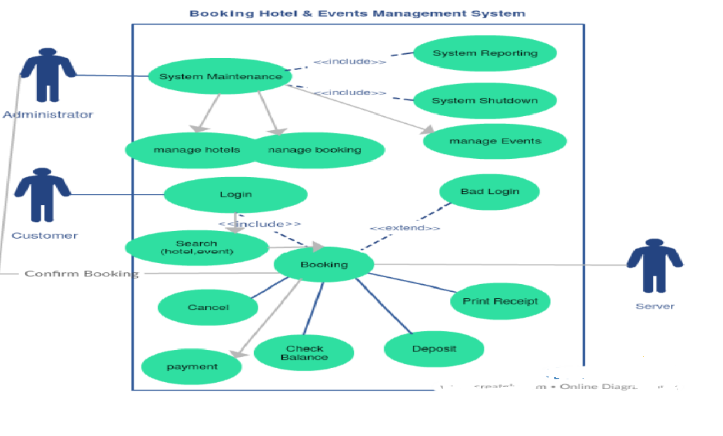

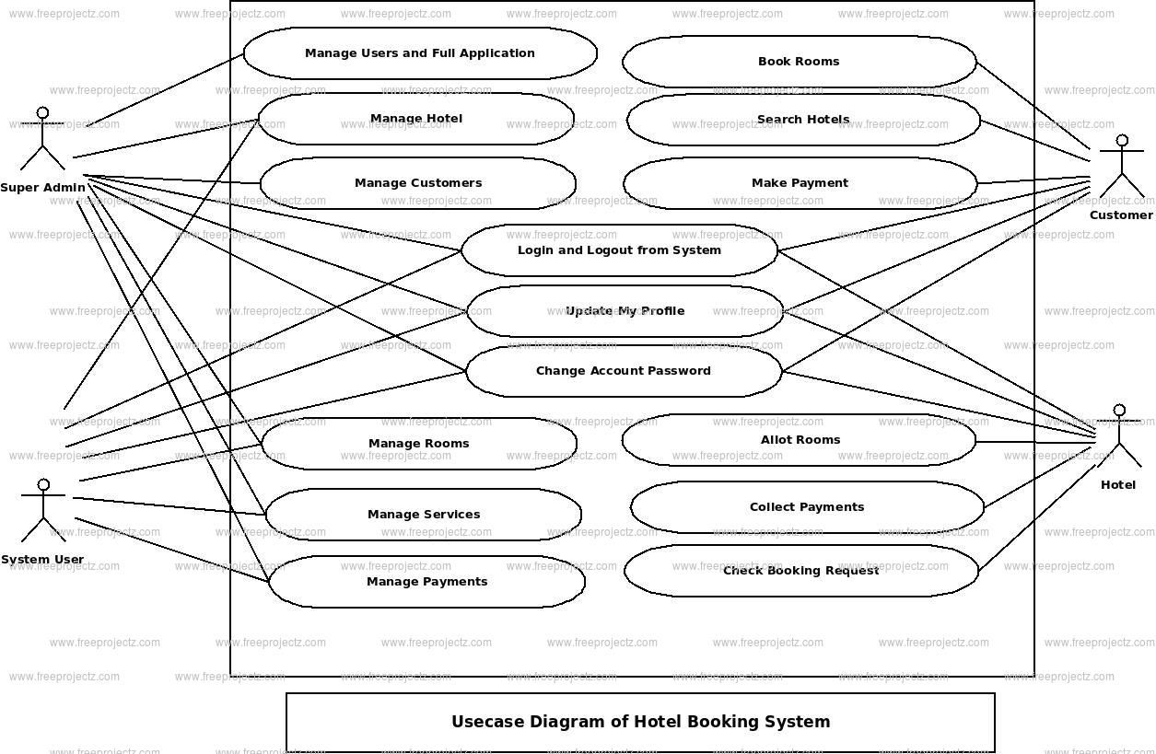

**Flow Diagrams**

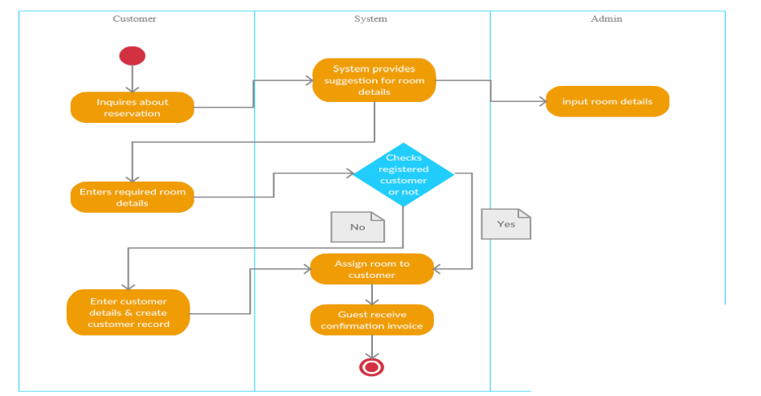

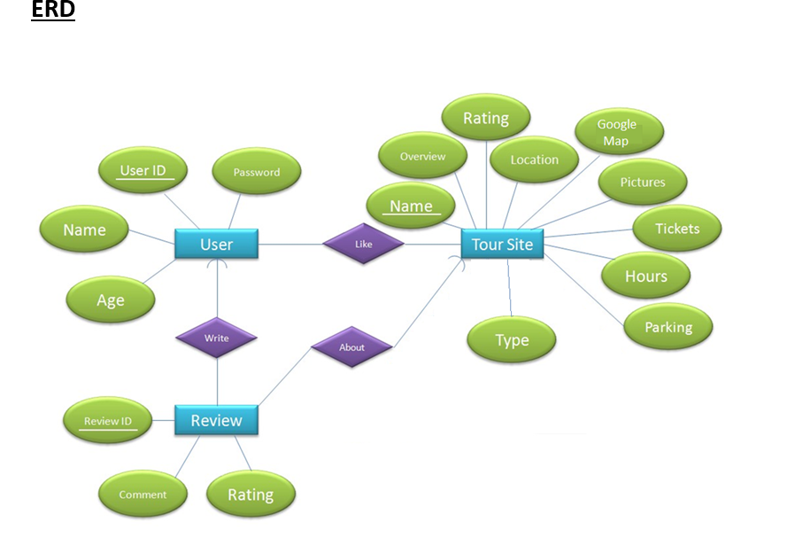

Conclusion

The project, Hotel Management System is a web-based application that allows the hotel manager to handle all hotel activities online. Interactive GUI and the ability to manage various hotel bookings and rooms make this system very flexible and convenient. The hotel manager is a very busy person and does not have the time to sit and manage the entire activities manually on paper. This application gives him the power and flexibility to manage the entire system from a single online system. Hotel management project provides room booking, staff management and other necessary hotel management features. The system allows the manager to post available rooms in the system. Customers can view and book room online. Admin has the power of either approving or disapproving the customer’s booking request. Other hotel services can also be viewed by the customers and can book them too. The system is hence useful for both customers and managers to portable manage the hotel activities.